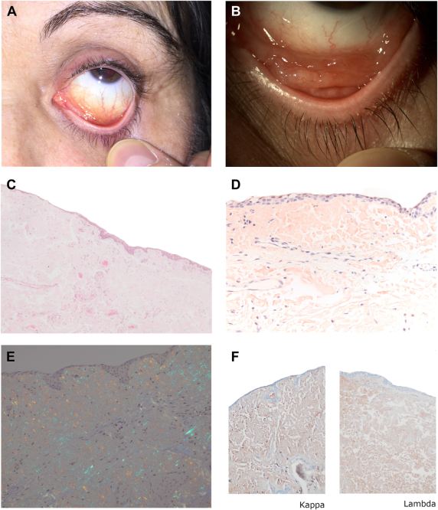

A 56-year-old woman presented with 14-month history of lower-lid mass in her left eye. On examination, a salmon-colored diffuselesion was identified in the inferior fornix (A-B). Histopathological studies revealed diffuse acellular, eosinophilic material below theconjunctival epithelium (C) staining positively with Congo red (D) and showing apple-green birefringence under polarized light. Immunohistochemistry evidenced positivity for kappa and lambda light chains (E-F). Systemic evaluation and fine needle aspiration cytology ofabdominal subcutaneous fat were performed with normal findings; systemic amyloidosis was excluded. Surgical excision was performed, and no recurrence was observed after 5 years of follow-up.Based on the provided images and clinical description please make an ophthalmic diagnosis for this patient. And output the diagnostic conclusions only

**Localized conjunctival amyloidosis.**